Initial Assessment of Learners Policy
For HALF Fish Training
Approved Centre
V5 April 2025

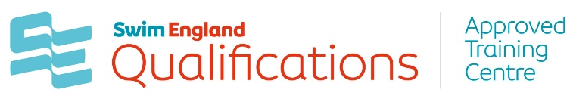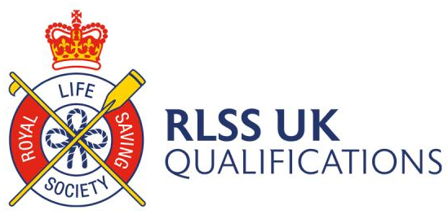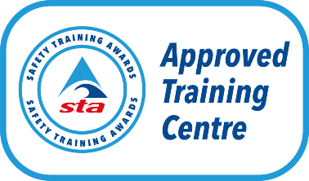



Initial Assessment of Learners Policy
This policy applies to all learners who enroll onto a course programme with HALF Fish Training. It details our commitment to making sure that every learner is working toward an appropriate programme of learning that has been discussed and agreed based on a thorough initial assessment.
Initial assessment forms one of the first experiences our learners have with us and will influence their initial impression and expectations of their course. It represents the first stage in the learning cycle and starts from the first contact we have with a prospective learner and continues to the point where we agree an individual plan of learning with them. The process of initial assessment is used to determine a learner’s suitability for a course, existing skill level and establish their starting point. This also provides the baseline on which to measure how a learner progresses.
Policy aim and purpose
All learners should undertake a period of initial assessment. The learner is at the centre of the process and it should fully engage them. It is a holistic process that takes place prior to the learner starting their course and may consist of (but not exclusive to) self-assessment activities, questionnaires, professional discussions, review of prior achievements, and appraisal of written, numerical and verbal tasks. The purpose is to ensure that collectively, initial assessment activities build up a picture of a learner’s current position and learning needs in relation to their chosen course based on a minimum of:
• Confirmation that the learner meets the prerequisites of their chosen course.
• Confirm Learner Existence and Eligibility Check
• Identify expected outcomes from undertaking the course and specific course requirements.
• Identify the learner’s career aspirations, how the chosen course supports this and potential further learning.
• Identify any recognised prior learning, achievements, skills, experiences in relation to the requirements of the learner’s chosen course.
• Identify the learner’s current skill level to be able to demonstrate the knowledge and behaviours required to meet the course outcomes.
• Identify any additional help that the learner requires to address barriers which may impact on their ability to meet the course outcomes (Barriers may include but are not limited to legal, financial, personal, technological or educational).
• Identify any reasonable adjustments that need to be applied to overcome barriers which may impact on the learner’s ability to meet the course outcomes.
- Confirm the learner’s ability to perform the different tasks and activities required at end point assessment.
- Identify the learner’s level of Maths and English in relation to the requirements of the course outcomes (Only applies to funded course learners as a prerequisite of the Education & Skills Funding Agency).
- Confirmation that a funded learner meets any prerequisites of the Education & Skills Funding Agency necessary to support their application.
The outcomes from the initial assessment should form the basis for agreeing eligibility and suitability for a learner to enroll on their chosen course. Assessment should also determine any further action or preparation by HALF Fish Training to accommodate the learner fully and allow them the opportunity to succeed by applying any necessary adjustments or support.

Responsibilities
• The HALF Fish team are responsible for ensuring that this policy is applied fairly and consistently by all team members involved in learner Initial Assessment.
• The HALF Fish Team are responsible for ensuring that any team members involved in learner Initial Assessment are trained this policy.
• The HALF Fish Team are responsible for ensuring candidates are treated fairly and consistently and will ensure this policy is implemented.
• The HALF Fish Trainings Quality Manager is responsible for learner eligibility decisions and all decisions must be recorded.
• HALF Fish Course Tutors are responsible for completing learner Initial Assessment with prospective learners and gathering supporting evidence.
• HALF Fish Trainings Tutors are responsible for following this policy in accordance with their training and completing prospective learner’s initial assessment to establish a programme of learning.
• HALF Fish Trainings Course Tutors are responsible for contacting all prospective learners with the outcome of the initial assessment, formal feedback and guidance within 48 hours via email.
• All prospective learners are responsible for adhering to agreed timeframes, providing accurate information and supplying genuine supporting documentation required for their initial assessment.
Equality & Diversity
HALF Fish Training is committed to promoting equality and diversity in its policies and procedures, adhering to current legislation e.g. The Equality Act 2010.
Learner Initial Assessment will always be carried out without regard to the nine protected characteristics:
1. Age
2. Disability
3. Sex
4. Gender reassignment
5. Pregnancy and maternity
6. Race
7. Sexual orientation
8. Religion or belief
9. Marriage and civil partnership
The Learner Initial Assessment Process
The learner Initial Assessment process should be:
Transparent, free from conflict of interest and relevant to the prospective learner and their chosen course.
All prospective learners wishing to enroll onto a course with HALF Fish Training must complete a learner initial assessment form including:
Personal details
Learner Existence and Eligibility Check
Choice of course/Timetable & Attendance Requirements
Personal Objectives
Coursework & Practical Assessment
Recognised Prior Learning
Prerequisites & Qualifications
Payment & Certification
Photography Consent
Barriers to learning
Criminal conviction declaration
Special needs or support & Special Considerations.

Initial learner assessment must be bought to the attention of the HALF Fish Training Quality Manager via email at halffish@hotmail.co.uk as soon as reasonably possible by the Course Tutor.

Learner Initial Assessment must be an evidence-based process and prospective learners should be assessed against agreed criteria, based on prerequisites of enrolment in accordance with the relevant National Governing body for the specific course and any associated funding providers (if applicable).
- No additional criteria will be introduced, and the Learner Initial Assessment process must be undertaken on a fair and consistent basis.
- No prospective learner should be approved who does not, as a minimum, meet the defined prerequisites of enrolment in accordance with the relevant National Governing body for the specific course and any associated funding providers (if applicable).
- To avoid any possibility of discrimination, learner initial assessment forms must not contain any information relating to sex, race. etc.
- Any skills tests (e.g. fitness or practical demonstrations of skills) must be directly related to the specific course and measured against the defined prerequisites of enrolment in accordance with the relevant National Governing body for the specific course.
- Candidates must be notified about the details of any skills test when they submit their initial enquiry. Where required, every effort must be made to make reasonable adjustments for prospective learners with disabilities.
- HALF Fish Training’s Quality Manager will take account of all sections of the learner initial assessment process, assessing prospective learner against the criteria.
- Learner initial assessment decisions are the sole decision of the HALF Fish Training Quality Manager and all decisions must be recorded.
- All prospective learners will be contacted via email by the course tutor with the outcome of the initial assessment, formal feedback, and guidance within 48 hours via email.
Documentation
The learner initial assessment process will be documented at each stage, resulting in a clear audit trail and transparency of decisions.
All documentation relating to learner initial assessment process will be retained for 6 months from the date of the commencement of the Initial submission by the prospective learner.
Documentation relating to successful learners will be transferred to their personal learner file. By keeping appropriate records HALF Fish Training can demonstrate in the event of an enquiry or complaint that appropriate procedures have been followed.
Information on candidates must be treated in the strictest confidence and restricted to those directly involved in the learner recruitment process.
HALF Fish Training will use appropriate ICT to manage the learner initial assessment process and therefore applicant data will be stored electronically, and all recruitment documentation will adhere to the requirements of GDPR.
Learner Initial Assessment Decisions
The HALF Fish Training Quality Manager is responsible for learner initial assessment decisions and all decisions must be recorded.
HALF Fish Training’s Quality Manager and course tutor will take account of all sections of the learner initial assessment, assessing prospective learner against the criteria.
All offers of training places with HALF Fish Training (verbal and written) are subject to the learner supplying relevant accompanying documentation (proof of prerequisites, certificates, I.D. etc.).
All prospective learners both successful and unsuccessful will be contacted via email by the course tutor with the outcome of the initial assessment within 48 hours via email.
After assessment has taken place, HALF Fish Training’ s course tutor will be required to provide feedback to the learner, discussing the results and provide support or further guidance on options available for further development.
A prospective learner can appeal a learner initial assessment decision if they choose. The specific details of the appeal should be bought to the attention of HALF Fish Training by email and by the learner who wishes to lodge the appeal. Any appeals should be sent to halffish@hotmail.co.uk Specific details should include the nature of the appeal and key dates, times and personnel involved. At this point HALF Fish Training’s Appeals policy should be followed.

Policy Review October 2023 V4
Policy Review April 2025 V5

Review April 2026

Documents and Forms linked to this policy :-
- HALF Fish Training Equality and Diversity Policy
- HALF Fish Training Appeals Policy
- HALF Fish Training Data Protections Policy
- HALF Fish Training Document Retention Policy
- HALF Fish Training Complaints Policy
- HALF Fish Training Recognition of Prior Learning Policy
- HAF Fish Training Learner Initial Assessment Form
- HALF Fish Training Skills Test Form
- HALF Fish Training Interview / Skills Test Reasonable Adjustment Notes Form

Sources of Information
- RLSS UK Qualifications Guidance Documents
- Swim England Qualifications Documents
- Safety Training Awards Qualification Documents

