Complaints Policy
For HALF Fish Training
Approved Centre
V10 April 26

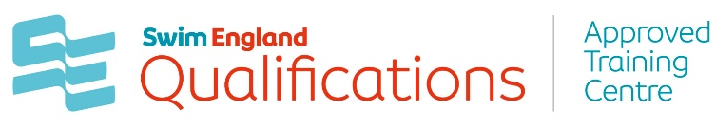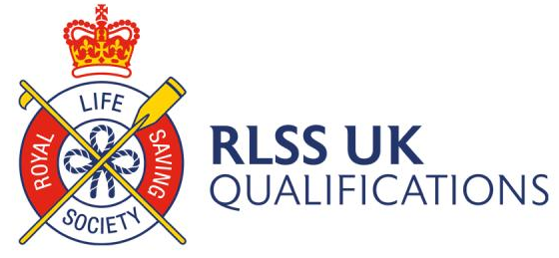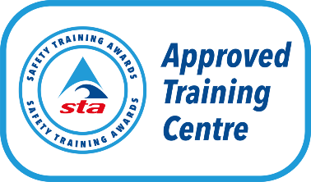



Complaints Policy
HALF Fish Training aims to provide an efficient and effective service to all.
However, whilst every care is taken to ensure high quality standards, we acknowledge that
there may be occasions where we fall short of expectations and individuals are not
completely satisfied. One of the ways in which we can continue to improve our service is by
listening and responding to the views of our customers and stakeholders anyone involved with any aspect of our course delivery, and in particular responding positively and putting mistakes right. If you feel that you have cause for concern, then We welcome positive or negative feedback from any individual that has been directly affected by our services. We strive to think our learners have confidence that we will listen to their views and act upon them accordingly. We take every care to ensure we are delivering a high standard of service but are aware that there may be occasions that we do not meet both yours and our expectations, in this instance please raise your concerns with us immediately so we can address them, respond positively, and rectify any mistakes made.
HALF Fish Training is committed to providing individuals directly affected by our services with the opportunity to provide feedback on whether or not standards have been met. Our customers must have confidence that they will be listened to, therefore all feedback received, both positive and negative, will be acknowledged. All expressions of dissatisfaction received will be treated as a complaint.
The aim of this policy is to provide a clear and structured process which highlights who can
make a complaint (the complainant), how they can make a complaint and what HALF Fish Training will do to seek a resolution to the complainant’s satisfaction.
Therefore, HALF Fish Training aims to ensure that:
• Making a complaint is as easy as possible
• The right response is provided, such as an explanation, apology or action taken
• Complaints are reviewed to improve service
Complaint’s procedure
Informal process
HALF Fish Training hopes that the cause of dissatisfaction may be resolved immediately and therefore the complainant should contact HALF Fish Training for an informal discussion, of which we will aim to resolve the concern by providing an explanation, an apology, or another desirable outcome. This is the informal stage of the complaint policy.
If a concern cannot be satisfactorily resolved informally, the formal complaints procedure
should be followed. It might be necessary at this stage to provide further information to
ensure the complaint is fully understood, thoroughly investigated, and allow for a
comprehensive response to be provided.

Formal process
Stage 1
Formal complaints are submitted in writing and marked for the attention of HALF Fish Training Quality and Compliance Leader, the key contact /centre coordinator, who will assume responsibility for the initial investigation. If you are unable to submit your complaint in writing, please contact the HALF Fish Training Quality and Compliance Leader directly by telephone. When submitting a complaint, the complainant must provide the following:
• Name, address and contact information
• Full details of the complaint such as the cause of dissatisfaction with operations,
actions or behaviour
• All supporting information such as relevant documentation, dates, locations, any
witnesses
• Details of any previous attempts to resolve the identified dissatisfaction
• What action has been taken to resolve so far.
The HALF Fish Training Quality and Compliance Leader will acknowledge the complaint in writing within 10 working days of receipt, record details on the complaints register and begin investigations into the cause of dissatisfaction. A response, inclusive of explanation and resolution, will be provided where possible within 20 working days of initial complaint acknowledgement.
To ensure a fair and thorough investigation, the duration will depend on the nature and
severity of the complaint received, and HALF Fish Training will notify the complainant as soon as possible if the investigation will take longer than expected.
At this point it is hoped the complaint will have been resolved however if not then stage 2 of the formal process will begin.
Stage 2
The complainant must notify HALF Fish Training if they want to move to stage 2 of this process within 10 working days of HALF Fish Training confirming the decision of stage 1.
The HALF Fish Training Quality and Compliance Leader will review the complaint for further investigation.

Acknowledgement of further investigation will be provided to the complainant in writing within five working days of receipt of the stage 2 complaint.
The complainant will also be notified of the individual responsible for the investigation.
HALF Fish Training will conduct a further investigation into the cause of dissatisfaction.

Upon cessation of investigations, HALF Fish Training will communicate directly with the complainant and provide an explanation or resolution.

This will be communicated to the complainant within 20 working days of receipt of the stage 2 complaint.

The duration of further investigation will depend on the nature and severity of the complaint and at this stage, the complexity of the response required.

In some cases, the investigation may take longer, and, in such instances, the complainant will be notified of the revised timescale.
If the complainant continues to remain dissatisfied with the response provided by the HALF Fish Training, the next step will be to pursue stage 3 of the complaints process and submit an appeal.
Stage 3
If a resolution is not reached at the end of stage 2, the complainant must notify HALF Fish Training within 10 working days of HALF Fish Training confirming the decision of stage 2.
At this stage an independent adjudicator will be agreed by the two parties, the complainant
and HALF Fish Training.
If an agreement cannot be reached within reason, then the complainant will be dismissed at
this point. Within reason means where for example the financial impact is too high on one or
both parties.

The independent adjudicator will review all previous materials and report on their decision within 20 working days. If more time is needed HALF Fish Training will notify the complainant of the revised timescales.
At this point the decision is final and the complaint is closed.
Contact details for HALF Fish Training

Post: | HALF Fish Training, c/o HALF Fish HQ @ Daisyfield Pools, Daisy Lane, Blackburn, BB1 5HB
Telephone: | (+44) 01254 433840
Email: | halffish@hotmail.co.uk
Website: http://www.half-fish-training.co.uk

Our Aim is to
Our aim is to provide our learners with a clear, precise process to follow when they feel the need to make a complaint and communicate effectively the process we will follow to resolve the complaint.
We aim to ensure:
• The complaints procedure is an easy process to follow and is prompt and efficient
• All complaints are treated as a dissatisfaction with our level of service
• The resolution is to the complainant’s satisfaction (explanation, apology, action taken) and
our staff when dealing with the complaint are courteous, consultative, and responsive
• Complaints and feedback received is reviewed in line with our quality assurance standards to help improve our products and services.
Everyone has the right to raise a complaint so this policy will define the stages and procedures you would need to follow, guidance is as follows:
The process you need to follow to raise a complaint
The appropriate person who this should be directed to
The timescales for the complaint to be investigated
How and when you will be notified of the outcome.
Raising Concerns and How to Make a Complaint
Please see the previous pages in this policy.
Complaints Escalation Procedures for each Awarding Body
Please refer to the appropriate website to find further information on how to escalate a complaint to the Awarding Organisation (AO).
Regulatory Escalation Procedures
Ofqual and Qualifications Wales (QW) Escalation Procedures
If a customer or learner is not satisfied with the outcome decision from an ATC and the Awarding Body they may escalate a complaint to the relevant regulator.
Please note the regulators are unable to overturn an assessment decision for regulated
qualifications.

Monitoring and review
This policy and its procedures will be reviewed annually to ensure it remains fit for purpose
and reflects the types of complaints that may arise, in accordance with the requirements set out by the qualification regulator, Ofqual. Should HALF Fish Training be notified by the qualification’s regulator, Ofqual, of failures that have been identified in the assessment process of another awarding organisation, HALF Fish Training will review its own processes to ensure a similar failure will not occur.

Policy Reviewed V8 October 2023
Policy Reviewed V9 April 2025
Review April 2026

Internal Documents and Forms
- HALF Fish Training Appeals Policy
- Learner Assessments Prior to Learning
- Learner Induction Form
- Individual Learner Learning Plan
- Learner Progress Report
- Learner Exit Interview Notes

Sources of Information
- RLSS UK Qualifications Guidance Documents
- Swim England Qualifications Guidance Documents
- STA Guidance Documents

Contact Information
RLSS UK Enterprises Ltd Redhill House, 227 London Road, Worcester WR5 2JG Telephone - 0300 323 0096

Swim England Qualifications Swim England Qualifications, Sportpark, 3 Oakwood Drive, Loughborough LE11 3QF Telephone - 01509 640493

Safety Training Awards Safety Training Awards Limited, Anchor House, Birch Street, Walsall, West Midlands, WS2 8HZ Telephone – 01922 645097

For Office Purposes | Document | Version Number | Comments on Amendments and/or Additions | Published Date
 | Complaints Policy | 9 | Updated Policy / Review | April 2025
 | Complaints Policy | 10 | Annual Review | April 2026

