Learner Existence and Eligibility Checks Policy
For HALF Fish Training
V7 April 2026

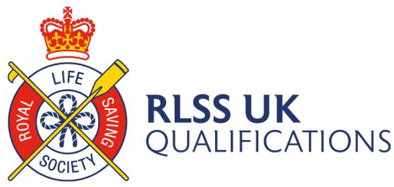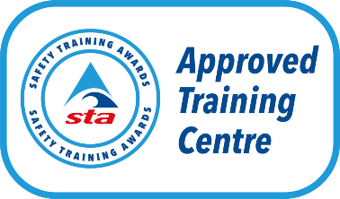



Learner Existence and Eligibility Checks (LEE) Policy
HALF Fish Training must check that the learners attending courses are who they say they are (Learner existence) and that they meet the entry requirements (Learner eligibility).
The eligibility and existence of all learners on a course must be established at the start of
their programme.
Learner Existence
Identification should be photographic, however sometimes this is not possible.
Please refer to the list below which are examples of identification the Safety Training Awards Qualifications deem acceptable:
• Passport
• Driving license
• ID card or other form of national ID
• National Insurance Card
• Photographic security pass for current place of employment
• Armed Forces service ID
• Birth certificate (and corresponding marriage certificate if applicable)
It is up to HALF Fish Training to select which forms of ID are acceptable and which are not, the above list is just some examples.
Learner Eligibility
In order for a learner to be eligible to attend any Awarding Body course leading to qualification they need to hold the relevant entry requirements detailed in the qualification specification.
HALF Fish Training, if called upon need to provide evidence to the Awarding Body of the qualification being undertaken that they conduct check to ensure learners fulfill the pre-requisites of the course leading to qualification.

Learners must provide evidence of their prerequisite on the first face-to-face delivery day of their course. The course educator will verify the validity of the evidence, make a note on the LEE Audit document and, where appropriate and in accordance with GDPR, take a copy of the evidence as well.
HALF Fish Training will be subject to at least one LEE Audit check each year, by the relevant Awarding Body.
The Awarding Body reserve the right to withhold certification until evidence that both existence and eligibility checks have taken place.

Policy Reviewed V5 October 2023
Policy Reviewed V6 April 2025
Policy Reviewed V7 April 2026

Policy Review April 2027

Internal Documents & Forms
1. HALF Fish Training Learner Checks Form
2. HALF Fish Training Appeals Policy

Sources of Information
1. RLSS UK Qualifications Guidance Documents.
2. Swim England Qualifications Guidance Documents.
3. Safety Training Awards Guidance Documents

