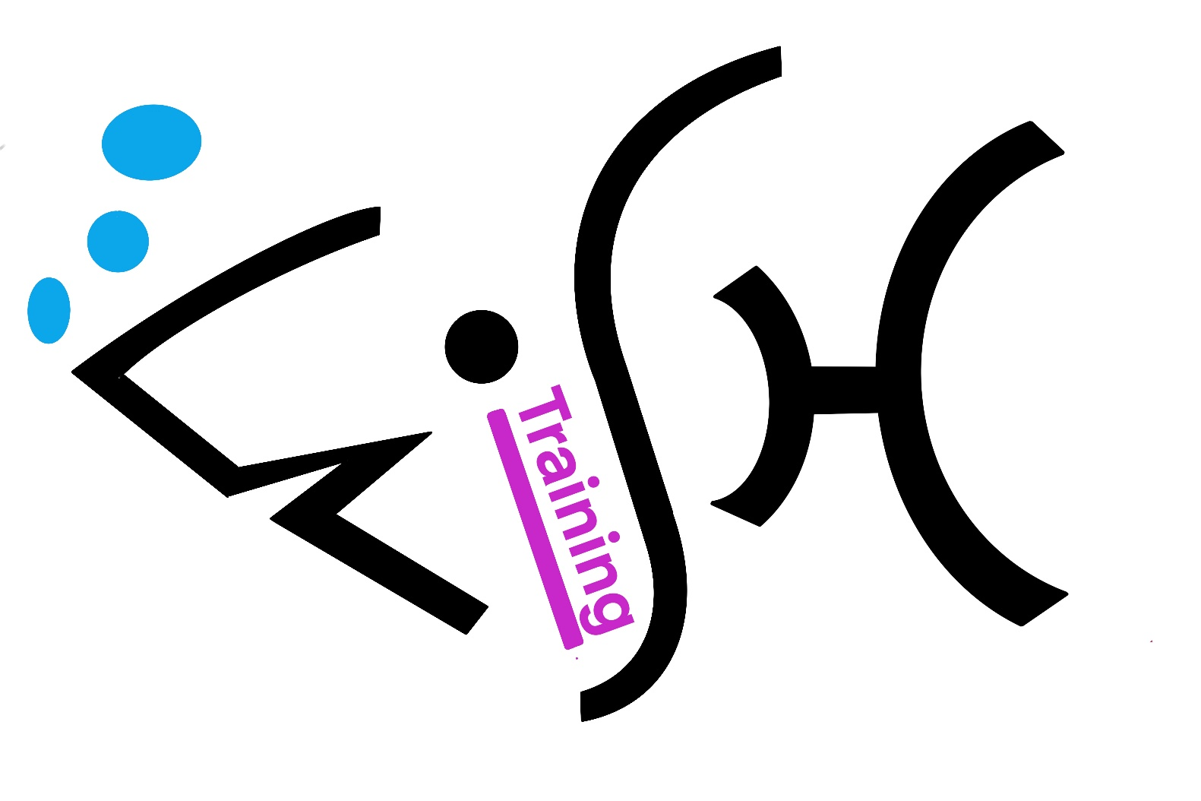
Individual Learning Plan

HALF Fish Training
V4 April 2025

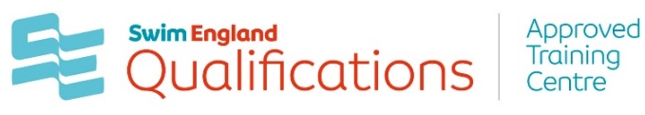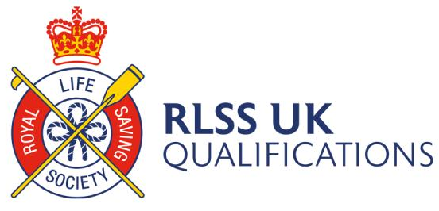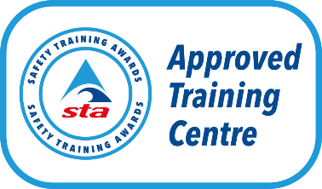



Ser |  | Completed By  Notes | Signature & Date of all parties
1 | Personal Details | Candidate  Completed on Learner Registration Form - Awarding Body of Qualification
2 | Qualification Specification | Provided by Awarding Body  Stored in Google classroom for course
3 | Learner Agreement | Candidate and Tutor
4 | Indication of Reasonable Adjustments or Special Considerations | Candidate  Completed on Initial Course Registration Form
5 | Outcomes and Personal Progress (Tracker)
6 | Action Plan from (5)  Learner Progress Review  Notes from any meetings leading from (5)
7 | Learners Time log  Indicating time on course and home / personal study | Tutor  Course Timetable provided by ATC
8 | End Point Review  Final Feedback  Confirmation of Results

