Equality and Diversity Policy
For HALF Fish Training
Approved Centre
V8 April 2026

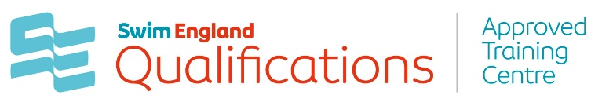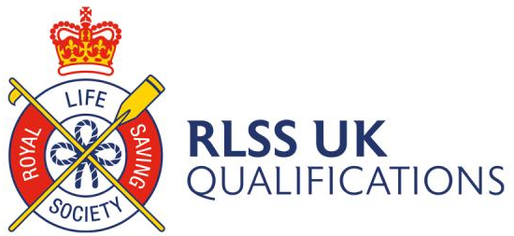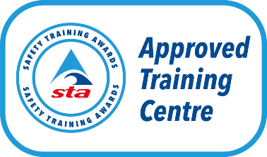



Equality and Diversity Policy
HALF Fish Training is committed to ensuring equal opportunities. All those representing HALF Fish Training, either directly or indirectly, are responsible for the implementation of this policy. HALF Fish Training are committed to the elimination of discrimination on any grounds including religion, belief, race, ethnicity, gender, age, marital or civil partnership status, pregnancy and maternity, sexual orientation, gender reassignment, disability, ability, occupation, political opinion, those with or without dependents and will not tolerate unlawful discrimination or unfair treatment, whether intentional or unintentional, direct, or indirect.
HALF Fish Training will ensure all working practices within and by HALF Fish Training promote equality and diversity, and that this policy is effectively communicated, reviewed, and amended.
With specific reference to the working practices of HALF Fish Training as a delivery organisation and to ensure equality of opportunity HALF Fish Training will:
• Ensure HALF Fish Training’s Equality and Diversity Policy is appropriately implemented at all times and available to all learners.
• Promote fair access to qualifications by ensuring HALF Fish Training’s Reasonable Adjustments and Special Considerations Policy is appropriately implemented at all times and available to all learners.
• Analyse relevant data to identify any areas that may be unlawful or unfair and intervene as appropriate.
• Minimise any barriers to participation in qualifications to promote equality and diversity.
• Ensure all qualifications are delivered and assessed free from bias, do not advantage or disadvantage any learners unfairly and use clear language.
• Ensure where equality and diversity allegations are made that a full and objective investigation takes place following appropriate procedures.

Investigative Procedure
Any instances where anyone considers treatment has been disrespectful in relation to specific characteristics, the specific details of this must be bought to the attention of HALF Fish Training by email and by the person who wishes to lodge this.
Details of this should be sent to the Quality manager at halffish@hotmail.co.uk.
Specific details should include the nature of the behaviour and key dates, times and personnel involved.
• The Quality Manager at HALF Fish Training will identify an investigating officer who will have no previous involvement with the specific circumstances of the case
• The investigating officer will carry out an investigation within 20 working days of the case being lodged. If longer is required due to the nature of the complaint or specific circumstances, then the investigating officer will inform the person lodging the case.
• The investigating officer will inform the person lodging the case of the outcome within 20 working days.
• If the person lodging the case does not consider the findings to be fair, then this can be referred to a mutually agreed independent person/organisation.
• This independent organisation will investigate the case and report their findings within 20 days. The outcome of this process will be final.

Policy Reviewed V6 October 2023
Policy Reviewed V7 April 2025

Review April 2026

For Office Purposes | Document | Version Number | Comments on Amendments and/or Additions | Published Date
 | Equality and Diversity Policy | 7 | Updated Policy / Review | April 2025
 | Equality and Diversity Policy | 8 | Annual Review | April 2026

The following policies or documents are implicated in this policy
- HALF Fish Training Appeals Policy
- HALF Fish Training Complaints Policy
- HALF Fish Training Special Considerations and Reasonable Adjustments Policy
Sources of Information
1. RLSS UK Qualifications Guidance Documents.
2. Swim England Qualifications Guidance Documents.
3. STA Guidance Documents.

