Internal Verification (IQA) Policy
For HALF Fish Training
V7 April 2026

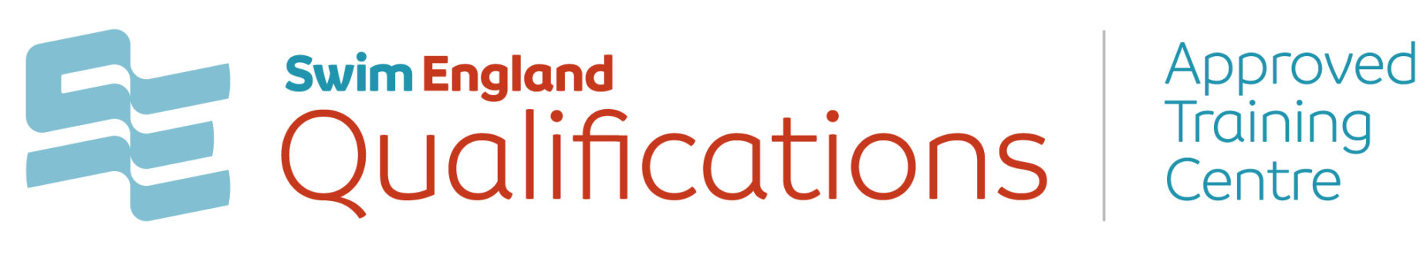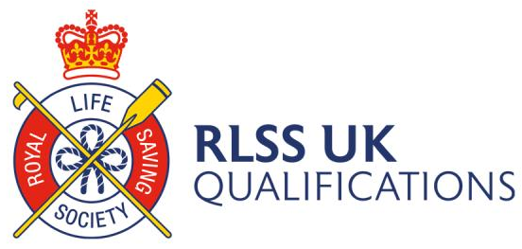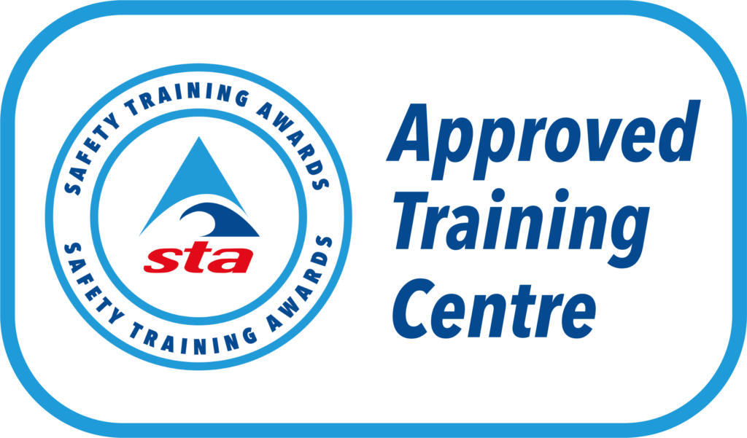



1

INTERNAL VERIFICATION POLICY
HALF Fish Training as an approved centre offering a variety of qualifications has effective internal verification processes in place to ensure that learners are assessed fairly and consistently, and that national standards are being met.

This Policy is designed to be used by HALF Fish Training Limited tutors to ensure they understand the IV policies and procedures and accurately manage internal verification in a consistent manner. This Policy may be applicable before or during course delivery.
Awarding Body’s will check that effective internal verification procedures are in place through both centre review and external verification systems. Internal verification may be called internal quality assurance or moderation, they are all equivalent.
Internal Verification Policy
HALF Fish Training is committed to the effective internal verification of all learning programmes. Appropriate systems are in place with all tutors, assessors and internal verifiers receiving effective training and standardization to ensure effective implementation. All learning programmes will be internally verified. This will include both assessment activities and assessment decisions.
The frequency and quantity of internal verification will be dependent on performance – which will be detailed in the internal verification schedule.

This policy has been designed to promote quality, consistency and fairness throughout the assessment and internal verification activities. It aims to ensure that standards of assessment are maintained over time.

This policy is applicable to everybody involved in assessment administration, management, verification, and moderation of any courses delivered at HALF Fish Training. The Internal Verification aims are to ensure effective management of assessment and verification processes, effective support for assessment personnel and to quality assure the outcomes of assessment in-line with the relevant Awarding Body.

All learning programmes will be internally verified. This will include both assessment activities and assessment decisions. The frequency and quantity of internal verification will be dependent on performance – which will be detailed in the internal verification schedule. The internal verifier will be responsible for establishing the IV sampling strategy, sampling plan and subsequent implementation.

What is Internal Verification?
There are many aspects to consider when setting up the process to internally verify a course.
These processes whatever they are must ensure
• That the learners receive a quality experience
• the resulting process is safe and accurate
Internal verification can include quality checks on all working practices involved in delivery. The minimum requirements are that there must be a system in place for internal verification of
• Assessment activities to ensure that they are all effective and accurate
• Assessment decisions to ensure they are accurate
Internal verification objectives

Ensure that each assessor and internal verifier has an effective induction.
Ensure effective appraisal and continued professional development for all members of the assessment and verification teams.
Ensure that the assessors and internal verifiers understand and follow all HALF Fish Training policies and procedures.
Ensure that all assessors and internal verifiers will embed equality and diversity throughout the internal verification process and within assessment activities.
Ensure quality via accurate and effective assessment of all candidates.
Monitor and ensure consistency of assessment outcomes via appropriate interpretation of the Awarding Body’s specific qualification specification.
In some cases, to evaluate the quality and consistency of assessment at different stages of the assessment process.
Maintain accurate and current records of internal verification and moderation.
To standardise all components of the assessment where appropriate.

Internal verification strategy
All personnel with internal verification responsibilities are suitably qualified to undertake this role.
All assessment and internal verification personnel are aware of the internal verification policy and strategic objectives and can facilitate the implementations.
Assessment and internal verification personnel development needs are taken into consideration.
Developing and newly qualified internal verifiers are given the necessary support to fulfil their duties effectively.
Assessors will be subject to IV depending on their ‘risk rating’
Every assessor will be subject to IV at least once in a calendar year. An assessor may be subject more often dependent on their risk rating. A risk rating will be given to each assessor by taking into consideration some of but not limited to the following; number of courses delivered, previous IV results, standardisation test results, previous EV results, brand new assessors.
For selected IV a random cohort of 25% of total learners on the course will be selected by the IV to produce a full portfolio to IV
HALF Fish Training will follow the relevant Awarding Body’s internal verification strategy relevant to the qualification.
Every assessor will have an internal verification that includes an observation of assessment activities (practical criteria) within every 12-month period.
All records and documentation of assessment and internal verification decisions are maintained for external verification purposes.
All assessment and internal verification records per candidate are maintained for a period of six years after certification has occurred, with the course documentation.

The following internal verification interventions aim to ensure the consistency of assessment across all assessors, at all sites.
Sampling of assessment evidence (written/ audio).
Observation of assessments (practical).
Candidate interviews. All learners will be informed of this procedure and its importance during the induction on their course.
The link between Internal Verification and External Verification
Internal Verification / Internal Quality Assurance
External Verification and Centre reviews are all part of the quality assurance procedures. External Verification and Centre reviews are conducted by the Awarding Body’s to check HALF Fish processes. Internal Verification is completed by HALF Fish Training and is required by the awarding body.
External Verification
This is completed at course level and includes sampling of assessment activities, assessment decisions and internal verification on specific courses. It focuses on
• Accuracy and effectiveness of assessment activities produced by HALF Fish Training
• Accuracy and effectiveness of assessment decisions produced by HALF Fish Training
• Effectiveness of Internal Verification by HALF Fish Training
Centre Review
This is completed on site at HALF Fish Training and includes visits which focus on
• The practices and processes of HALF Fish Training
• Continuous improvement, which is a critical component of the process itself.
Effective Internal Verification
In establishing a successful Internal Verification process, the following points were considered:
• Identification of effective Internal Verifiers who are responsible for implementing the process. The centre contact has been appointed as the IV coordinator.
• Production of an effective Internal Verification policy
• Acknowledgement of supporting documentation that shows a clear audit trail of decision making and actions
• Production of an internal verification schedule of assessment activities and assessment decisions
• Production of a training and standardisation plan for all those involved in Internal Verification
• Production of an improvement plan in conjunction with the centre review
Internal Verifiers
HALF Fish Training Internal verifiers will:
• Have experience of effective assessment
• Have experience of the subject matter of the learning programme
• Understand the purpose and requirements of HALF Fish Training's Internal
Verification policy
• Have effective resources to carry out the Internal Verification process effectively
• Be able to give effective feedback leading to improvement
• Be able to support effective decision making with appropriate sanctions where needed
Our Internal Verifiers hold one or more of the following qualifications
• 1st 4 sport Level 3 Certificate in Internal Verification Practice in Sport
• Level 4 Award in the Internal Quality Assurance of Assessment Processes and
Practice (which replaces the previous V1 qualification)
• The equivalent such as D34, V1 etc

Supporting Internal Verification
The Awarding Body will review the following documents as part of the External Verification or centre review. Ofqual, the regulatory body may ask to review them too.
The documents need to show:
• Those assessment activities are fit for purpose - this will be included in the Internal
Verifiers' initial report for each course. The assessment tasks will be verified before
they are issued to learners. This will ensure that learners can generate evidence that meets both the assessment criteria and covers the unit content fully.
• That assessment decisions are accurate and consistent. This will be detailed in the
Internal Verification report.
• That any remedial action is undertaken where necessary. Records of action points will
be built into the verification schedule and the training and standardisation plan.
• That all those involved are supported and developed where necessary.
• That sanctions can be enforced where necessary
Internal Verification Schedule
As Internal Verification a planned process it should
• Be short, medium and long term in planning
• Include all assessors
• Include all units over time
• Include a range of learners
• Include all disciplines and levels
• Involve either face to face or remote sampling
• Include some random sampling
- Should take no longer than seven days to complete
These spot checks can confirm effective practice and offer further support for improvement. These random checks can also guard against malpractice. Each Tutor will be verified for 25% of the course. A random learner from each course may also be verified for 100% of assessment decisions made.
Training and Standardisation Plan
All of those involved in assessment in assessment should be offered training and standardisation to allow for development and continuous improvement. Standardisation is an activity to ensure that all Assessors are marking to national standards consistently. This process maximises both reliability and accuracy of certification. This can be done through a series of activities, such as:
Dual assessment: This is where two Assessors assess the same Learner and compare assessment decisions. This could also be where the Internal Verifier observes a practical assessment in real time or through video and discusses assessment decisions. It is good practice for internal verification of practical activities to be included within the internal verification schedule. This could be completed through dual assessment.
Blind assessment: This is where assessors all assess the same evidence independently and then compare responses. Development plans can then be produced to support those that need it. Furthermore, any Assessors that are unsuccessfully standardised could then either not assess or only assess under supervision until the required standard is met.
Cross assessment: This is where assessors exchange marked Learner evidence and comment accordingly. Again, remedial action can be identified and actioned as appropriate. This information is then communicated to HALF Fish Training so that they are aware of the level of accuracy of assessment for the Assessors they decide to use. It is worth noting that an assessor cannot internally verify assessment activities they have developed or assessment decisions they have made as an assessor. Learners need to be informed at the start of their programme that the work they produce to be assessed will be verified both internally and
externally if the course is chosen as part of the sample. All internal verification material will be stored securely so that trend analysis can be completed and provide information for the training and improvement plan.
The Improvement Plan
An integral part to internal verification is continuous improvement. Given all the documentation and processes highlighted in this policy already, the final step is to put together an action plan to ensure that the learning programme and the learner experience improves year on year.
The action plan could include:
• Short, medium and long term targets
• A rationale for these targets
• Timescales and milestones
• Responsibilities
• The opportunity for review
• Those involved
• Outcomes
Reviewed V6 October 2023
Reviewed April 2025 V6
Reviewed April 2026 V7

Policy Review April 2027
Documents and Forms linked to this policy :-
- STA Guidance Documents
- HALF Fish Training ATC / IQA Form

Sources of Information
- RLSS UK Qualifications Guidance Documents
- Swim England Qualifications Documents
- Safety Training Awards Qualification Documents

