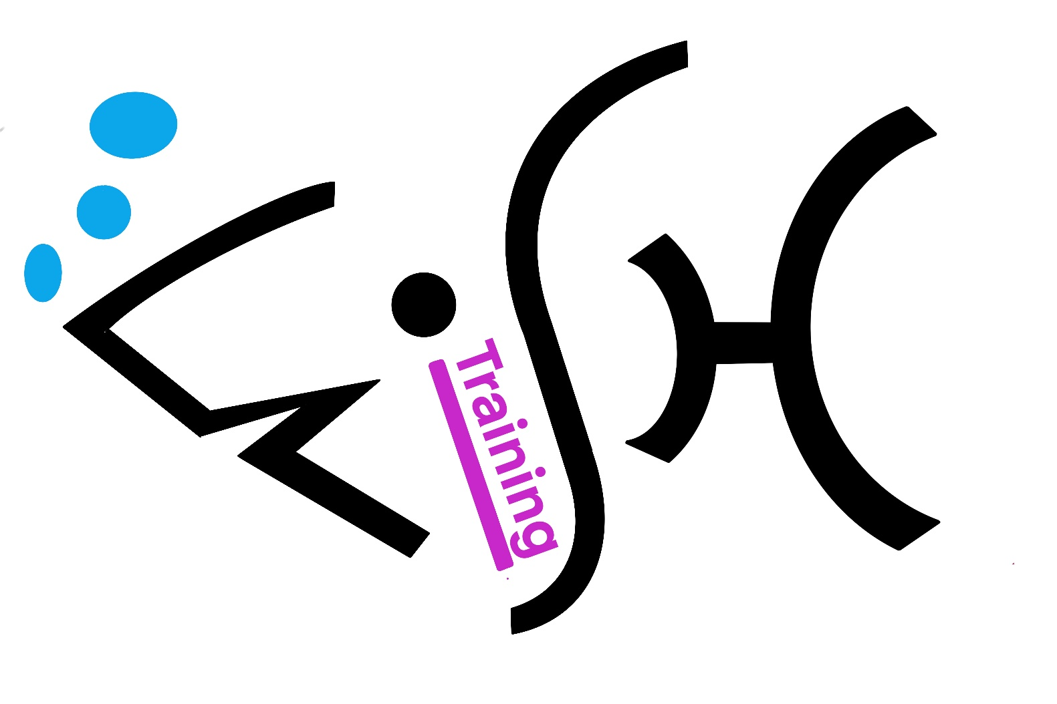

Cookies Policy
For HALF Fish Training
Approved Training Centre
V5 April 2026

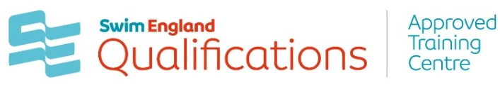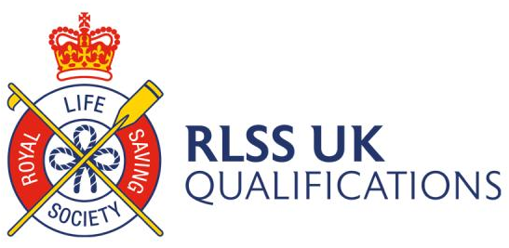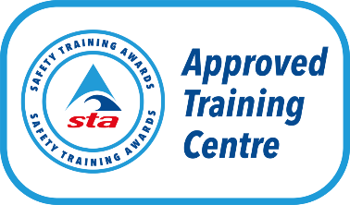



The European Community recently introduced legislation to protect the privacy of web users

by limiting how websites can use cookies HALF Fish is committed to protecting your privacy. As part of this commitment, we are providing you with information about the cookies we use, so that you can make informed decisions.

The information below should be read in conjunction with our Privacy Policy and Terms and Conditions.

What are cookies?

Cookies are small text files that our website(s) or services provided for us by other companies put on your computer. The information in them helps us to improve your experience of using our website and learning with us. Many of our cookies are deleted when you log out of your learning or close your web browser. None of our cookies contain any of your personally identifiable information.

Because you are using our website(s) we assume that you are happy for us to use cookies in this way.

If you are not happy, then you should either not use our website(s), set your web browser to not accept cookies from HALF Fish or use your web browser’s anonymous browsing setting (this is called ‘Incognito’ in Google Chrome, ‘InPrivate’ in Internet Explorer and ‘Private Browsing’ in Firefox).

For more information on cookies, how to control the use of them in your browser and how to browse the internet anonymously visit the All About Cookies website.

Because our learning systems rely on cookies to deliver your courses effectively you give us consent to use cookies as outlined below when you purchase or enroll on a block (HALF Fish). We will not provide technical support to learners who choose to cookies and then encounter issues with their learning.

You will not be able to purchase courses from the HALF Fish website if you set your
browser to not accept cookies as our ecommerce system uses them to process transactions. We are unable to facilitate purchases by any other method (e.g. telephone sales) or provide technical support to users who choose to block HALF Fish cookies.

What cookies HALF Fish uses:

Session Cookies

We use a number of session cookies to provide functionality including, but not limited to, remembering who you are when you have logged into our website(s) or learning systems, to identify you when you move from one HALF Fish, system to another, to greet you by name on screen, to optimise the effectiveness of our web servers and to remember the items you have put into our shopping basket.

We consider these cookies to be strictly necessary for the secure and efficient operation of our website(s) and learning systems and make your experience of using them easier and quicker.

If these cookies are blocked or disabled, then much of the functionality of our systems will be broken.

Persistent Cookies

We use a number of persistent cookies to provide functionality including, but not limited to, returning you back to the point in your learning you had reached the last time you logged out, to show you content you had looked at on a previous visit to make it easier to find it again, to make sure you are only invited to complete a web survey occasionally and that you don’t see alerts or messages repeatedly during a single web visit.

If these cookies are blocked or disabled then our systems will still be usable, but the user experience will be severely degraded.

DoubleClick (Google)

This cookie is used on a small number of pages on the HALF Fish website to track
the effectiveness of our Google Adwords, and Google Sponsored Link advertising.

For more information on how to permanently opt-out of DoubleClick placing this cookie on your computer visithttp://www.google.com/policies/privacy/ads/#toc-optout or install the Google Advertising Cookie Plugin for your browserhttp://www.google.com/ads/preferences/plugin/

Social network cookies

Some pages on our website(s) contain social network ‘share’ or ‘like’ buttons. The social network may set a cookie (or cookies) on your PC when you click on one of these buttons.

In order to implement these buttons on our website(s) we use code which is hosted by the relevant social network. If you are a member of some of these networks, they may use this code to track that you have visited our website(s) whether you click the buttons or not.

(HALF Fish) does not control these cookies or the underlying code. You should
check the privacy statement of the relevant social network before clicking them and/or to find out how they track their members’ behaviour using these elements and how to opt out of this functionality.

For Office Purposes | Document | Version Number | Comments on Amendments and/or Additions | Published Date
 | Cookies Policy | 4 | Updated Policy / Review | April 2025
 | Cookies Policy | 5 | Annual Review | April 2026

