Malpractice and Maladministration Policy
For HALF Fish Training Approved Centre
V10 April 2026

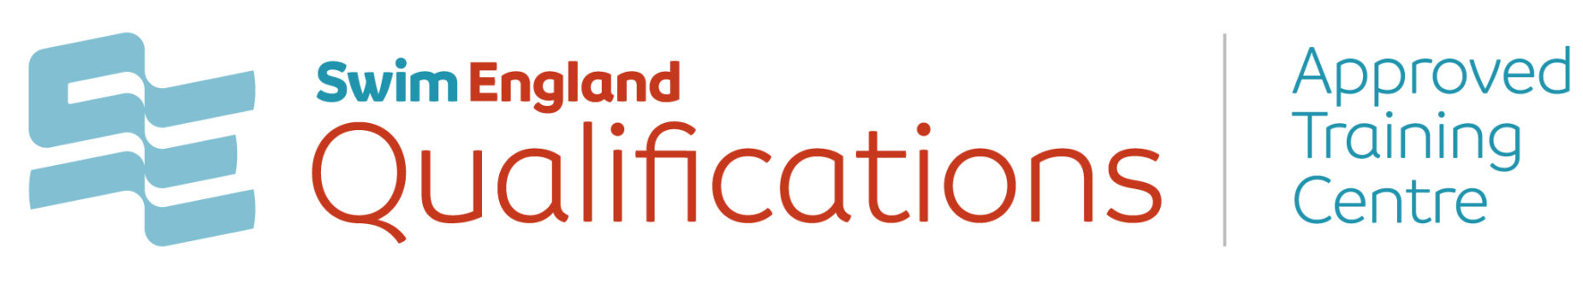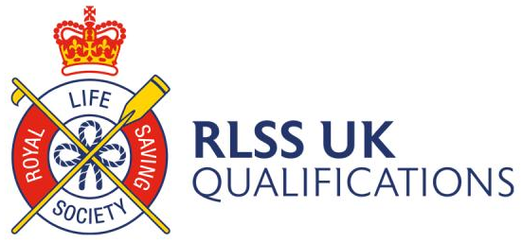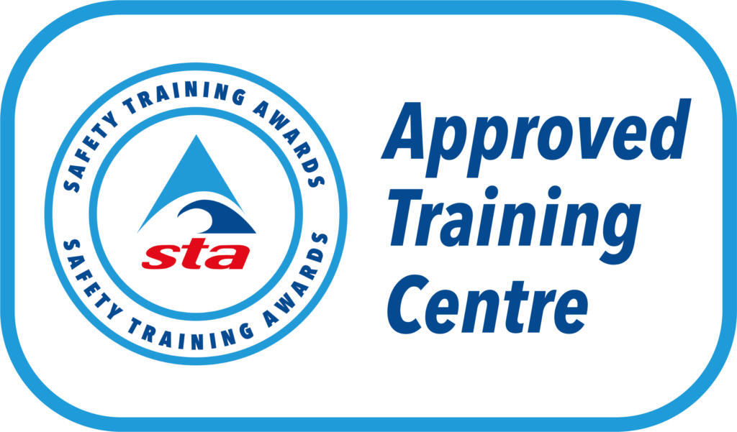



Malpractice and Maladministration Policy
HALF Fish Training are committed in its service provision to offer the highest quality, ensuring access to fair assessment for all learners and the continued full compliance
with the General Conditions of Recognition – Ofqual and Qualification Wales.
Policy Aim and Purpose
The aim of this policy is to safeguard the integrity and credibility of the qualifications offered, to ensure that any potential malpractice or maladministration is identified,
prevented, corrected and/or mitigated in every aspect of the delivery, development and
assessment by HALF Fish Training.

This policy provides a robust and transparent framework for the identification and management of malpractice and maladministration by:
• Providing the means to identify and resolve malpractice and maladministration
• Establishing clear standards for dealing with malpractice and maladministration
• Reducing the possibility of malpractice and maladministration.
This policy applies to HALF Fish Training, Awarding Body representatives working with HALF Fish Training, learners and any other individual involved with the development, delivery and assessment of HALF Fish Training materials and courses.
Definition of Malpractice and Maladministration
Malpractice is any deliberate or neglectful, default or other activity which undermines the integrity and validity of assessment, verification and the certification at the qualification. Malpractice can occur at HALF Fish Training, and at learner level. Examples of malpractice can be found in appendix 1.
Maladministration is any activity which results in unintended non-compliance with regulations and requirements. Recurring instances of maladministration may be considered serious enough to be treated as malpractice. Examples of maladministration can be found in
appendix 1.

HALF Fish Training are responsible for establishing correct procedures to deal with any potential and / or actual cases of malpractice and / or maladministration and for ensuring that any cases are escalated to the Awarding Body, in line with the current policy on their website.
Reasonable actions must have been taken to prevent instances of malpractice and / or
maladministration. All staff, tutors, assessors, learners or IQAs must be made aware of this policies contents and the procedures relating to this topic.
Centre compliance with this policy and how they take reasonable actions to prevent and/or
investigate instances of malpractice and / or maladministration, will be monitored through external quality assurance procedures.
Failure to co-operate may lead to certificates not being issued to learners and future course registrations not being accepted.
A failure to comply and to report any suspected or actual malpractice and / or maladministration cases or have in place effective arrangements to prevent such cases may lead to sanctions being imposed on the centre.

Reporting suspected instances of malpractice and / or maladministration procedures
If malpractice and / or maladministration is suspected or there has been an actual case, the appropriate Awarding Body must be informed immediately, utilising the ‘Malpractice and Maladministration’ report form that is available on the Awarding Body’s website / electronic account, please ensure all relevant evidence is provided to support the case.
Please refer to the appropriate website to find further information on how to escalate a
case of Malpractice and/or Maladministration.
If a centre has conducted an initial investigation prior to notifying the Awarding Body they must ensure that all personnel involved in the initial investigation are competent and have no personal interest in the outcome of the investigation.
Reports can be made by centre staff, tutors, assessors, learners or IQAs. HALF Fish Trainings Quality Co-ordinator must also be notified of any suspicion of malpractice and / or maladministration, so they can apply their own procedures where appropriate.
Investigation and Management of Malpractice and Maladministration
The procedures put in place by HALF Fish Training as an Approved Training Centre, coupled with quality assurance controls (external verification and Centre Review), have been carefully designed to monitor HALF Fish Training as an Approved Training Centre, their arrangements and ability to competently deal with preventing and investigating any instances of malpractice or maladministration.

HALF Fish Training has established a process for investigating alleged cases that have been raised, which comprises of five stages:
Stage 1: Notification of an alleged case of malpractice or maladministration
Stage 2: Management and investigation of allegation
Stage 3: Report
Stage 4: Management of confirmed cases of malpractice or maladministration
Stage 5: Appeals
On all occasions when information regarding an allegation is received by HALF Fish Training and in turn the Awarding Body, it will be treated as a potential case for malpractice or maladministration until an outcome has been reached through the investigation stage.
Where there are grounds to suspect malpractice or maladministration against a HALF Fish Training representative, that individual risks suspension of their duties and an investigation by HALF Fish Training about the professional misconduct.
Where there are grounds to suspect malpractice or maladministration at HALF Fish Training, as an Approved Training Centre, registrations and learner certification may be suspended until the investigation has been completed and if necessary, any sanctions applied by the appropriate Awarding Body.
Where there are grounds to suspect malpractice or maladministration against a learner,
certification may be suspended until the investigation has been completed and if necessary
any sanctions applied, these may include exclusion of work submitted as part of the assessment process, not accepting any future course bookings, or disqualification from the programme being undertaken.
Stages of Investigation
Stage 1: Notification of a case of malpractice or maladministration
HALF Fish Training is responsible for any matters relating to the conduct of the learner or tutor whilst undertaking the qualification. HALF Fish Training will investigate the allegation in compliance with their published policy and procedures.
Notification of the allegation must be submitted, through email, accompanied by any supporting information for review. This may be by the learner or course tutor.
Evidence should be sent to: The Quality and Compliance Leader, the Key Contact, of HALF Fish Training. If the allegation relates to the Quality and Compliance Leader of HALF Fish Training notification of the suspected malpractice or maladministration should be sent to the relevant Awarding Body.
Once the Allegation Form has been received, HALF Fish Training will check that
the required information has been submitted, acknowledge receipt (within 10 working days)
and record the details. In all cases HALF Fish Training will protect the identity of the informant.

Stage 2: Management and investigation
The Quality and Compliance Leader of HALF Fish Training, the Key Contact, will review all information provided and conclude if there is a case of Malpractice or Maladministration. If the investigation involves the Quality and Compliance Leader of HALF Fish Training an appropriate independent reviewer will be appointed to examine the allegation.
During the investigation there may be:
• A request further information
• Interviews conducted with individuals involved in the investigation in person or by
telephone
• An Approved Training Centre visit, if instigated by the Awarding Body, which will be chargeable to the Approved Training Centre. Pending the outcome of the investigation, HALF Fish Training may apply sanctions as detailed in the HALF Fish Training Sanctions Policy.
Stage 3: Report
HALF Fish Training will aim to provide feedback within 30 working days of acknowledgement of the allegation form being received.
In some cases, the investigation may take longer, for example, if an Approved Training
Centre visit is required. In such instances all concerned parties will be advised of the revised timescale.
HALF Fish Training is expected to fully cooperate with all investigations and requests for information. If this does not happen HALF Fish Training’s Approved Training Centre status may be withdrawn.
Stage 4: Appeals
HALF Fish Training have an appeals procedure that can be applied if there is disagreement in the outcome of a malpractice/maladministration investigation.
An appeal must be based on reasonable grounds which relate directly to the case in question. The following would be accepted as reasonable grounds:
• The case was not dealt with using the published policy and procedure
• Further evidence (including medical evidence) has come to light which changes the
basis of the decision
The following do not, by themselves constitute grounds for an appeal:
• The individual did not intentionally cheat
• The individual has an unblemished academic record
• The individual could lose a university place
• The individual regrets his/her actions
HALF Fish Training reserves the right to reject an appeal at this point if there is not
any further evidence to consider or if the grounds for the appeal are weak or unjustified.
Further information on appeals may be found in the Appeals Policy.

Policy Reviewed October 2023 V8A
Policy Reviewed April 2025 V9

Review April 2026
For Office Purposes | Document | Version Number | Comments on Amendments and/or Additions | Published Date
 | Malpractice and Maladministration Policy | 9 | Updated Policy / Review | April 2025
 | Malpractice and Maladministration Policy | 10 | Annual Review | April 2026

Documents and Forms linked to this policy :-
- Learner Assessment Prior to Learning
- Learner Induction Form
- Learners Individual Learning Plan
- Learners Progress Report
- Learners Exit Interview

Sources of Information
- RLSS UK Qualifications Guidance Documents
- Swim England Qualifications Documents
- Safety Training Awards Qualification Documents
- Swim England Examples of Malpractice and Maladministration
- Swim England Reasonable Adjustments Notification
- Swim England Allegation Form
- Swim England Malpractice / Maladministration Event Record

Appendix 1: Examples of Malpractice and Maladministration
The following situations are examples of malpractice or maladministration; to decide which
one depends on whether the actions are deliberate (malpractice) or unintentional
(maladministration).

Failure to adhere to HALF Fish Training and/or Approved Training Centre eligibility criteria
Actions required by an External Verifier not being met within agreed timescales
Failure to carry out delivery, assessment, or internal verification in accordance with Awarding Body requirements
Failure to adhere to HALF Fish Training learner registration and certification procedures
Fraudulent claim for certificates
Withholding of information from the HALF Fish Training which is critical to maintaining the rigor of quality assurance
Insecure storage of assessment materials
Unauthorised use of equipment and materials in assessments
Giving improper assistance to learners
Submission of false or inaccurate information to gain a qualification or unit(s) including authenticity statements
Tampering with learner’s work
Failure to carry out delivery, assessment and internal quality assurance in accordance with Awarding Body requirements
Deliberate failure to adhere to ATCs agreements including tutor and IQA contracts
Late learner registrations
Plagiarism of any nature by learners - failure to acknowledge sources properly and/or the submission of another person’s work as if it were the learner’s own
Examples of Learner malpractice could include:
- Plagiarism - failure to acknowledge sources properly and/or the submission of another person’s work as if it were the Learner’s own.
- Collusion with others when an assessment must be completed by individual Learners and/or evidence must relate to that individual Learner.
- Copying from another Learner (including using ICT to do so).
- Impersonation - assuming the identity of another Learner or a Learner asking another person to assume their identity during an assessment.
- Inclusion of inappropriate, offensive, discriminatory, or obscene material in assessment evidence. This includes vulgarity and swearing that is outside of the context of the assessment, or any material of a discriminatory nature (including racism, sexism and homophobia).
- Inappropriate behaviour during an internal assessment that causes disruption to others. This includes shouting and/or aggressive behaviour or language.
- Frivolous content - producing content that is unrelated to the question in worksheets or online coursework.
- The procurement of evidence from a third party (e.g., essay mill, ghost writing) which is submitted as the Learner’s own work.
Fraudulent Certificate claims
Failure to meet our published timeframes for certification
Any action likely to lead to an adverse effect
Breach of confidentiality
Persistent instances of maladministration
Intentionally withholding information from the Awarding Body
A loss, theft of, or breach of confidential assessment materials
Defacing, amending or falsifying assessment records
Deliberate failure to adhere to reasonable adjustments, or inappropriately assisting a learner
A deliberate act or omission of withholding or delaying information which is required to assure the Awarding Body of Trident Lifesaving Club’s ability to deliver and assess qualifications
Misuse of Awarding Bodies logo or misrepresentation of a centre relationship with the Awarding Body and/or the recognition and approval with the same
Maladministration is defined as any activity, neglect, default or other practice that results in the centre, tutor, assessor, learner or IQA not complying with the Awarding Body requirements, tutor and /or IQA agreement and the general conditions of recognition, or
regulatory principles.
Maladministration is in effect any activity or practice which results to non-compliance with
administrative requirements and regulations, this includes the application of persistent mistakes or poor administration within the centre including inappropriate learner records.
Examples of maladministration could include, but are not limited to:
Persistent failure to adhere to Awarding Body certification procedures
Inaccurate certificate claims
Persistent failure to adhere to our Awarding Body recognition and / or qualification requirements and / or associated actions assigned to that centre
Failure to keep auditable records in accordance to Awarding Body requirements
Failure to adhere to delivery, assessment and certification requirements
Failure to adhere to register learners in accordance with Awarding Body procedures
Unreasonable delays in responding to requests and / or communications from the Awarding Body

Appendix 2: Allegation Form -is may be used or the information contained in an email to the Key Contact
Informant information should include information relating to the person submitting the
Allegation Form. If you are a learner, please indicate this clearly under informant role.

Declaration:
I confirm that the information in this form is accurate, to the best of my knowledge, and
that the centre will provide arrangements in accordance with the guidance given by the
HALF Fish Training.
Please return to Quality and Compliance Leader of HALF Fish Training,
Allegations, HALF Fish HQ @ 20 Station Road, Great Harwood, Blackburn, BB6 7BA or email - halffish@hotmail.co.uk

Name:
Role:
Address:
Telephone number:
Email address:

HALF FISH TRAINING Approved Training Centre
Qualification title
Details of the allegation (continue on a separate page if required)

Signature: Printed:
Date:

Appendix 3: Maladministration/Malpractice Event Record
HALF Fish Training Maladministration/Malpractice Event Record

Approved Training Centre: HALF Fish Training
Key Contact: Shelley Whitehead
Date of Event

Description of the event:

Additional commentary from the Approved Centre:

(not mandatory))

Risk:

Maladministration or Malpractice:

Reason behind decision:

What actions will the Approved Centre put in place to ensure this doesn’t happen again:

What actions will the Awarding Body put in place to ensure secure certification | TBC following the ATC’s response in the box above

ATC Key Contact Signature: | Date
Awarding Body Signature: | Date

Number of Maladministration events  in last 24 months including this event: | Number of Malpractice events in last 24  months including this event:

