Cancellation and Refund Policy
For HALF Fish Training
Version 4 April 2026

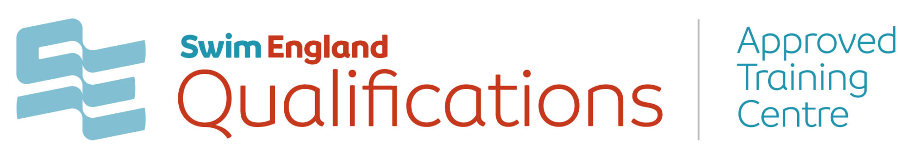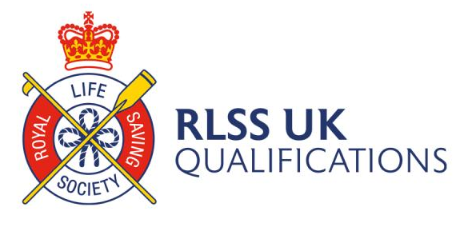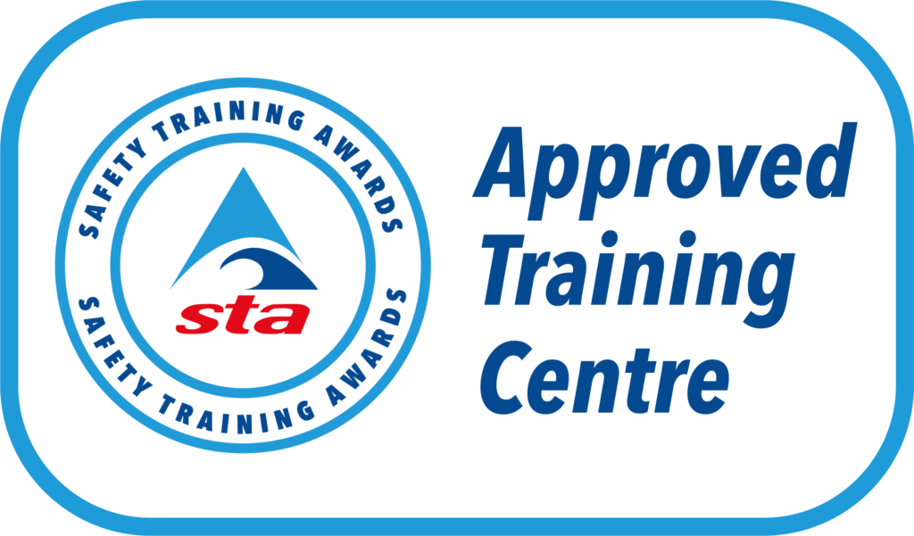



Cancellation and Refund Policy
HALF Fish Training aims to provide an efficient and effective service to all, along with a fair and reasonable policy with regards to cancellation and refunds. The aim of this policy is to provide a clear and structured process which highlights who can cancel, how they can cancel and what HALF Fish Training will do to refund course fees. Therefore, HALF Fish Training aims to ensure that:
- Cancelling a course is as easy as possible.
- Communication is timely and clear.
- The right response is provided, such as a confirmation of cancellation and refund, and where possible an alternative resolution if cancellation and refund are not possible.
Practical Courses – Terms & Conditions
By completing and sending an enrolment form for a course and making a payment in full or an instalment fee, a learner is agreeing to the following Terms and Conditions:
A learner has the right to cancel a practical course booking at the following terms:
- Within the 14-calendar day cooling off period from the date on which the contract of
purchase is concluded (receipt of paid course fees). If a learner chooses to cancel within this period, they will receive a full refund within 30 days.
- After the 14-calendar day cooling off period from the date on which the contract of purchase is concluded (receipt of paid course fees). An admin fee of 25% of the total course price applies (which will not be refunded), any remaining deposit will be refunded.
- A learner must request any practical course cancellation 30 days before the course start date.
- The cooling off period does not apply within a 30-day period prior to the course starting date.
- A learner is not eligible for any refund if a request for cancellation is received less than 30 working days before the course starting date regardless of the cooling off period.
Online Courses (Distance Learning) Terms & Conditions
Under this refund policy and under guidance of the Consumer Contracts Regulations 2013, a learner may cancel a purchase of an online course at the following terms:
- Within the period of 14-calendar day (cancellation period) from the date on which the contract of purchase is concluded (receipt of paid course fees). If a learner chooses to cancel within this period, they will receive a full refund within 30 days.
- A learner is not eligible for any refund if a request for cancellation is received less than 14 working days before the course starting date.

After the start date of a course (practical or online)
Once a learner attends any portion of any course, HALF Fish Training cannot grant a refund. All refund requests can be sent to halffish@hotmail.co.uk if a learner feels that they have exceptional circumstances.
Please note that a refund request, is a request only, and will not guarantee a refund or partial refund.
The learner enrolled may be required to provide proof of change in circumstance or additional evidence to support their request.
Learner Postponing or Transferring a Course
If a learner wishes to postpone or transfer a course, all postponement or transfer requests can be sent to halffish@hotmail.co.uk for review by the HALF Fish Training’s Quality Manager no less than 30 working days before the course starting date.
A learner is not able to make a request for course postpone less than 30 working days before the course start date.
Course Provider Cancelling a Course
HALF Fish Training reserves the right to cancel a course if number of learners have not reached the minimum required to run the course effectively. This decision will be made, and learners notified no less than 14-calendar days before the start date of the course.
HALF Fish Training also reserves the right to cancel in the event of an unforeseen circumstance which disables a safe training environment. In the event of a cancellation, HALF Fish Training will either arrange for an alternative course date or offer a full refund of the course fees paid.
Refund Procedure
All refunds will take up to 30 days to process.
Once a learner attends any portion of any course, HALF Fish Training cannot grant a refund.
All refund requests can be sent to halffish@hotmail.co.uk for review by the HALF Fish Training’s Quality Manager if a learner feels that they have exceptional circumstances preventing them from attending their course. Please note that a refund request, is a request only, and will not guarantee a refund. The learner enrolled may be required to provide proof of change in circumstance or additional evidence to support their request.
Formal refund process
Stage 1
Formal refunds are submitted in writing and marked for the attention of HALF Fish Training’s Quality Manager who will assume responsibility for the initial investigation at halffish@hotmail.co.uk adhering to the timing detailed in sections 1-7 of this policy.

When submitting a refund request, the learner must provide the following:
Name, address and contact information.
Full details of the refund such as the course name, venue, dates and invoice number.
All supporting information such as relevant documentation.
Details of any previous attempts to obtain a refund.
What action has been taken to resolve so far.

HALF Fish Training’s Quality manager will acknowledge the refund in writing within 10 working days of receipt, record details on the refund register and begin the refund investigation. A response, inclusive of explanation and resolution, will be provided where possible within 20 working days of initial request acknowledgement. To ensure a fair decision is made, the duration for the refund will depend on the particulars of the request received and HALF Fish Training will notify the learner as soon as possible if the investigation will take longer than expected. At this point it is hoped the refund request will have been resolved however, if not then stage 2 of the formal process will begin.
Stage 2
The learner must notify HALF Fish Training if they want to move to stage 2 of this process within 10 working days of HALF Fish Training confirming the decision of stage 1.
The HALF Fish Training’s Quality manager will inform the HALF Fish Training’s Directors to review the refund request for further investigation.
Acknowledgement of further investigation will be provided to the learner in writing within 5 working days of receipt of the stage 2 complaint.
The learner will also be notified of the individual responsible for the investigation.
The HALF Fish Training’s Directors will conduct a further investigation into the particulars of the request. Upon cessation of investigations, the HALF Fish Training’s Directors will communicate directly with the learner and provide a final resolution. This will be communicated to the learner within 20 working days of receipt of the stage 2 refund request. Following the Director’s final decision, the refund request is closed.

Vexatious and Persistent Correspondence
HALF Fish Training offer a transparent cancellation and refund procedure and will keep learners informed throughout any investigation or request. However, learners must allow sufficient time to carry out a thorough investigation or request review.
HALF Fish Training will not engage with abusive or persistent correspondence from complainants, once a decision has been reached.
Repeated contact with no new evidence and /or abusive correspondence from a learner will be considered as vexatious correspondence.
Where correspondence and /or behaviour are deemed to be vexatious, HALF Fish Training will refer the learner to this policy, explaining that if the communication continues in this manner all correspondence will cease.
Contact details for HALF Fish Training
Email: halffish@hotmail.co.uk
Review – April 2027

For Office Purposes | Document | Version Number | Comments on Amendments and/or Additions | Published Date
 | Cancellation Policy | 3 | Annual Review | April 2025
 | Cancellation Policy | 4 | Annual Review | April 2026

Internal Documents & Forms
1. HALF Fish Training’s Appeals Policy (Candidate Copy).
2. Learner Assessment Prior to Learning
3. Learner Induction Form
4. Learner Individual Learning Plan
5. Learner Progress Report
6. Learner Exit Interview
Sources of Information
1. https://www.which.co.uk/consumer-rights

