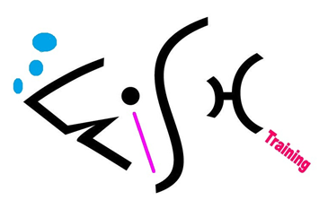

Enquiries & Appeals Policy
For HALF Fish Training
Approved Training Centre
V9 April 2026

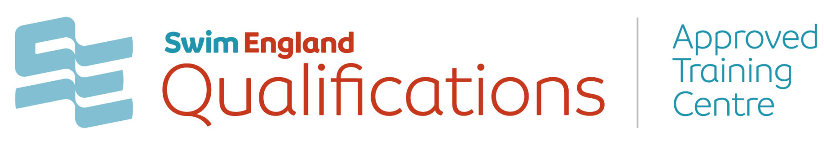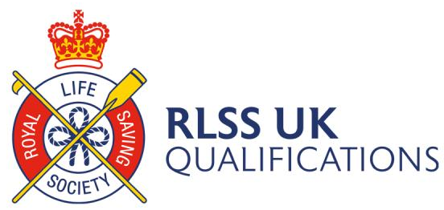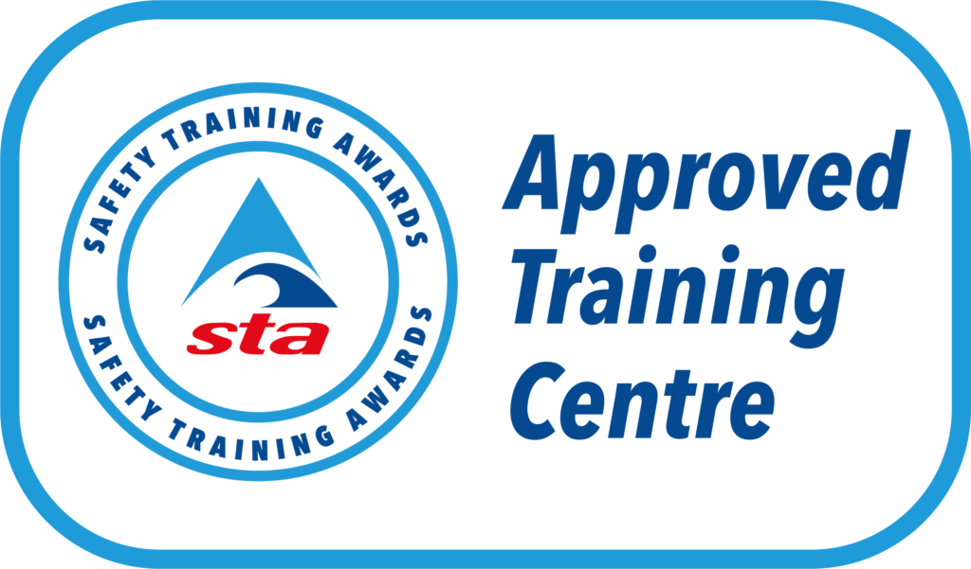


Enquiries & Appeals Policy

HALF Fish Training is committed to providing an efficient and high standard of service to all. It is our aim to ensure that all assessment outcomes are fair, consistent, and reliable based on the valid judgements of the assessor using the assessment strategy for the appropriate Awarding Body qualification on offer. However, occasions may arise where the learner may wish to question a decision.
HALF Fish Training aims to ensure that all decisions are fair, consistent, and based on valid judgements, however, acknowledges that there may be occasions where a learner may wish to question a decision made.
A learner can appeal:
• A Tutor assessment decision.
- An internal verification decision
- Or any other decision made by HALF Fish Training.

HALF Fish Training will ensure:
• Assessments are carried out by assessors who have the appropriate qualifications, knowledge, understanding, and skills, and the assessments are valid for the subject or qualification in question
• Assessment evidence is authentic, solely being produced by the learner in question
• Consistency of assessment decisions covering all assessors over time
• Appeals are heard by individuals that have the appropriate competence to make decisions in each individual case and have had no prior involvement, or a personal interest in the case.
Everyone has the right to appeal if they believe that their assessment decision, or a decision following a malpractice or maladministration investigation is incorrect. This policy will define the stages and procedures you would need to follow, guidance is as follows:

The process you need to follow to submit an enquiry or appeal
• The timescales for an enquiry or appeal
• How and when you will be notified of the outcome. The process you need to follow to submit an enquiry or appeal
• The timescales for an enquiry or appeal
• How and when you will be notified of the outcome.

HALF Fish Training will accept an appeal in relation to the following:
• Appeals against results of assessment or internal quality assurance monitoring
• Appeals against a decision made relating to a reasonable adjustment or special considerations application
• Appeals against decisions relating to any action taken against a learner following an investigation into malpractice or maladministration.
Firstly, we advise all learners to discuss any concerns or enquiries relating to the result of the assessment with the assessor to resolve the issue. If you are not satisfied with the outcome, then please contact the ATC Co-ordinator for further advice and guidance or refer to the guide within this policy.

Procedure to Escalate Appeals to Awarding Bodies
Please refer to the appropriate website to find further information on how to escalate an enquiry or appeal to the Awarding Organisation (AO).
A learner may escalate an enquiry or appeal after they have exhausted the ATCs enquiries and appeal process and remain dissatisfied with the outcome. Any enquires and appeals must be submitted to the appropriate Awarding Organisation within 28 days of the final results being issued to the learner.
Regulatory Escalation Procedures
Ofqual (England) and Qualifications Wales (QW) Escalation Procedures
If a customer or learner is not satisfied with the outcome decision from an ATC and the Awarding Body’s Enquiries and Appeals procedures, they may escalate an appeal to the relevant regulator.
Please note the regulators are unable to overturn an assessment decision for regulated
qualifications that are offered by an Awarding Organisation (AO).
This policy will outline clear guidance for the learner should they wish to enquire or appeal against an assessment decision, they will have clear guidelines on how to do so.

In the first instance, learners wishing to appeal against results must follow HALF Fish Training’s appeals process through to the end only then when the learner continues to remain dissatisfied with the outcome should they contact relevant awarding body for the qualification they are working towards. This can be Swim England Qualifications, Safety Training Awards or RLSS UK. All learners will be informed of this procedure and its importance during the course, and the policy is available on the website.
Stage 1: Enquiry
In the event of a learner wishing to appeal a decision the following steps should be taken:
• The specific details of the appeal should be bought to the attention of HALF Fish Training by email and by the learner who wishes to lodge the appeal. Any appeals should be sent to halffish@hotmail.co.uk
Specific details should include the nature of the appeal and key dates, times and personnel involved.
• HALF Fish Training will identify an investigating officer who will have no previous involvement with the specific circumstances of the appeal.
- A Learner may nominate an appropriate representative to act on their behalf only if they are unable to represent themselves, for example by reason of disability, on medical grounds, or because they are under the age of 18. Learners wishing to nominate a representative should do so at the beginning of the process with HALF Fish, giving a clear reason why they cannot represent themselves
• The investigating officer will carry out an investigation within 20 working days of the appeal being lodged. If longer is required due to the nature of the appeal or specific circumstances, then the investigating officer will inform the learner lodging the appeal.
• The investigating officer will inform the learner lodging the appeal of the outcome within 20 working days of the appeal being lodged.
• If the learner lodging the appeal does not consider the findings to be fair, then the case can be referred to a mutually agreed independent person/organisation. This independent person will investigate the claim and report their findings within 20 days of the appeal being referred to them.
• HALF Fish Training will notify the relevant Awarding Organisation of an appeal by completing an Appeal Form corresponding with the relevant Awarding Organisation within 10 working days.
• A representative from the relevant Awarding Organisation will review this decision in the first instance and determine if the appeal should progress to stage 2.
• The representative from the relevant Awarding Organisation will notify the individual appealing of the enquiry within 10 working days where possible.
Stage 2: Formal Appeal
If the learner remains dissatisfied after receiving the outcome of the enquiry, they can pursue a formal appeal against the decision. All appeals must be made in writing and within 10 working days of the relevant awarding body confirming the enquiry outcome.
• The representative from the relevant Awarding Organisation will acknowledge the formal appeal within 10 working days of receipt of the formal appeal.
• The representative from the relevant Awarding Organisation will establish an appeals panel, consisting of one or more individuals, who will be competent of acting on the panel and have no personal interest in the outcome of the appeal.
• The representative from the relevant Awarding Organisation will inform the individual of the result of the appeal within 20 working days of receipt of the formal appeal and payment.
• If the panel is unable to complete its investigations and determine an outcome within the 20 working days, HALF Fish Training will be advised of the extent of any delay. Please note that charges may apply and will be dependent on the specific Awarding Organisation.

Stage 3: Panel Investigation
If the stage 2 formal appeal decision is not agreed by the individual or the relevant Awarding Organisation then a panel investigation can be arranged along with representation from the individual and relevant Awarding Organisation.

The decision from the panel will be final and charges may apply.
Monitoring and review
This policy and its procedures will be reviewed annually to ensure it remains fit for purpose,
reflects the types of appeals that may arise and how the process for application is managed, in accordance with the requirements set out by Ofqual/Qualification Wales.
For Office Purposes | Document | Version Number | Comments on Amendments and/or Additions | Published Date
 | Enquiries and Appeals Policy | 8 | Updated Policy / Review | April 2025
 | Enquiries and Appeals Policy | 9 | Annual Review | April 2026

The following policies are implicated in this policy
1. HALF Fish Training Appeals Policy
2. HALF Fish Training Learner Assessment Prior to Learning
3. HALF Fish Training Learner Induction Form
4. HALF Fish Training Individual Learning Plan
5. HALF Fish Training Learner Progress Report
6. HALF Fish Training Learner Exit Individual
Sources of Information
1. RLSS UK Qualification Guidance Documents.
2. Swim England Qualification Guidance Documents.
3. Swim England Enquiries and Appeals Policy V8 June 2021
4. STA Guidance Documents – Enquiries & Appeals Policy (120822).

Contact Information

RLSS UK Enterprises Ltd
Redhill House, 227 London Road, Worcester WR5 2JG
Telephone - 0300 323 0096

Swim England Qualifications
Swim England Qualifications, Sportpark, 3 Oakwood Drive, Loughborough LE11 3QF
Telephone - 01509 640493

Safety Training Awards
Safety Training Awards Limited, Anchor House, Birch Street, Walsall, West Midlands, WS2 8HZ
Telephone – 01922 645097

Ofqual (England)
Complaints, Ofqual, Earlsdon Park, 53-55 Butts Road, Coventry, CV1 3BH
Telephone – 0300 303 3344

Appendix 1: Appeal Form
This form should be completed by the individual appealing. If you are a learner wishing to
appeal against the assessment decisions by an educator you should contact HALF Fish Training who ran the course and follow their appeals process.
Please give as much detail as possible when completing the form, if further evidence is
required you will be asked to add additional commentary.

Name:
Role:
Address:
Telephone number:
Email address:
Qualification Title
Dates of course / Assessment

HALF FISH TRAINING Approved Training Centre:
Type of Appeal:
An individual assessment decision | Y / N
Decision made by HALF Fish Training: | Y / N
Details of the appeal:

Declaration
I confirm that the information in this form is accurate, to the best of my knowledge, and that the ATC will provide arrangements in accordance with the guidance given by HALF Fish Training.

Signature: Printed:
Date:
Please return to HALF Fish Training, Appeals, HALF Fish HQ @ Daisyfield Pools, Daisy Lane, Blackburn, BB1 5HB or email halffish@hotmail.co.uk

