

Retention of Records Policy
For HALF Fish Training
Approved Training Centre
April 2026 V4

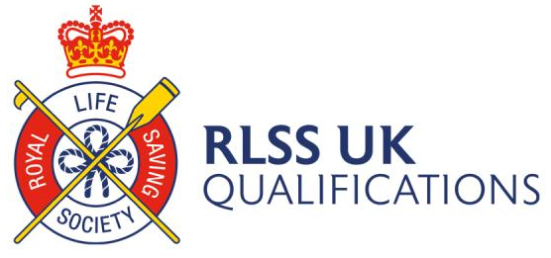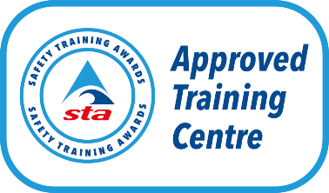



Retention of Records Policy
General
This policy is for use by HALF Fish Training to ensure we are retaining evidence in a fair and consistent manner, in relation to the Awarding Organisations we work with.
As an Approved Training Centre (ATC), we must maintain rigorous quality assurance and control arrangements as outlined in the General / Standard Conditions of Recognition by our Regulators, Ofqual and Qualification Wales (Regulators).
We will be monitored as an ATC to ensure we are acting in accordance with the Conditions. This includes keeping records of learners’ registration, achievements, internal verification and ensuring that the specified levels of attainment set for the qualifications we deliver, remain consistent over time and between similar qualifications.
ATC Retention of Records Learner Data
Registration records must be retained for all learners registered with us and should include details required by us for registering a learner. They must be retained and made available to the Awarding Organisations we work with and / or our Regulators for up to five years following registration.
This information may include:
• Date learners started their qualification (e.g. course / cohort start date)
• Learner name, ULN (where applicable) and date of birth
• Learner contact details
• Evidence of Learner eligibility
• Evidence of Learner pre-requisites (if applicable)
• Date Learners were registered with the Awarding Organisation
• Date certificates were claimed by the ATC
• Learner Outcomes
Workforce Data
The following information must be retained and made available to us and / or our Regulators for up to five years following Learner registrations. This information may include:
• Name of all individuals involved in the teaching, learning, assessment and internal verification of the learners • Role they undertook (e.g. Tutor and / or Assessor or IV)
• Evidence of any appropriate / required qualifications
• Evidence of any appropriate licenses (such as a tutor License or licence to practice letter (if applicable)
Learner Samples
Representative samples of learner work for the ATCs own monitoring and standardisation activities. There should be a minimum sample of one complete learner portfolio for each qualification the ATC delivers each year. The portfolio must be a copy rather than the original, and the learner’s written agreement for its retention must be obtained. They must be retained and made available to the Awarding Organisation and / or their Regulators if requested.
Assessment Evidence
Assessment evidence must be retained and made available to Awarding Organisations and / or their Regulators for up to one year following registration.
This information may include:
• A copy of the Assessment Task versions used (including references to how they are mapped to Learning Outcomes / Assessment Criteria)
• Summary of assessment decisions to include formative and summative decisions and when and by whom the decisions were made
Learner Portfolios
Learner work is the property of the learner and therefore cannot be retained indefinitely. However, access may be required by the ATC, the Awarding Organisation and / or their Regulators for purposes of appeal, audit, or on-going monitoring. It is advisable to either retain copies of learner work (e.g. portfolios) and / or require learners to keep their work for a short period (e.g. up to six months) following final outcomes and / or the issuing of certificates.
Internal Quality Assurance Records
Internal Quality Assurance Records must be retained and made available to the Awarding Organisation, and / or their Regulators for up to one year following registration.
This information may include:
• Internal Verification / Quality Assurance Sampling Plans
• Internal Verification sign-off of Assessment Tasks (if applicable)
• Internal Verification reports
• Standardisation activities
Data Protection (Incorporating GDPR)
The retention of any information and evidence described above should always be in line with the requirements of current Data Protection Legislation and General Data Protection Requirements and aligned to the individual organisations related policies and procedures.
Monitoring and review
This policy and its procedures will be reviewed annually to ensure it remains fit for purpose,
reflects the types of appeals that may arise and how the process for application is managed, in accordance with the requirements set out by Ofqual/Qualification Wales.
Policy Reviewed V2 October 2023
Policy Reviewed V3 April 2025
Policy Reviewed V4 April 2026

Review April 2027

The following policies are implicated in this policy
1. HALF Fish Training Appeals Policy
2. HALF Fish Training Learner Assessment Prior to Learning
3. HALF Fish Training Learner Induction Form
4. HALF Fish Training Individual Learning Plan
5. HALF Fish Training Learner Progress Report
6. HALF Fish Training Learner Exit Report Individual
7. HALF Fish Training Learner Existence Form
8. HALF Fish Training Record of Attendance Form
9. HALF Fish Training Course Registration Form
10. HALF Fish Training Data Protection Policy
11. Any further HALF Fish Training’s documentation which is referred to by implication in this policy relating to IQA / EQA and Centre Review Procedures
Sources of Information
1. RLSS UK Qualifications Guidance Documents.
2. Swim England Qualifications Guidance Documents.
3. Swim England Retention of Records Policy V1 May 2022
4. Safety Training Awards Qualifications Guidance Documents.

