Learner Cancellation Policy
For HALF Fish Training
Approved Centre
V6 April 2026

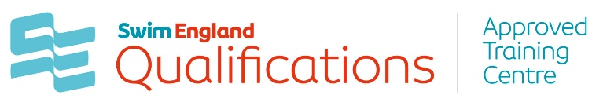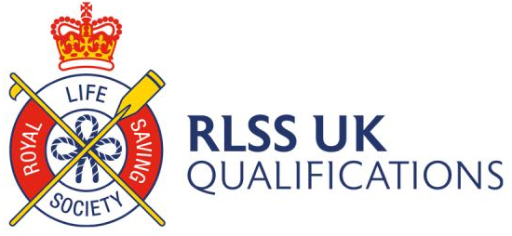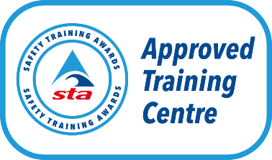



Learner Cancellation Policy

All Learners agree to abide by the General Rules and Conditions for the use of the venue. All learners take part at their own risk. Additional fees may be incurred if you are deemed not yet competent, pre-requisites are the responsibility of the learner and are indicated on website detailing qualifications requirements. You will be asked to provide evidence that you meet the pre-requisites. If pre-requisites are not met, you will be asked to leave. No refund will be issued.
HALF Fish reserves the right to amend the timetable, the presenter and / or venue to suit the needs of the course. The cost viability of a course is based on the learners on the programme. No refunds will be given for anyone who has decided the programme is not the correct one for them.

Learner Cancellation and Transfer Policy

Please note the following cancellation policy applies should you cancel your place on this course:
Cancelled less than 31 days prior to the start of the course a full refund will be issued minus a £25 administration fee for seminars and a charge of £90 for Swim England Level 1; £125 for Swim England Level 2; £90 for STA Level 2; and £175 for Swim England Level 3 qualifications – the fee is commensurate to the course registration fee to the awarding body, plus an administration fee.
Cancelled less than 14 days prior to the start of the course no refund will be given except in the event of illness / injury (for which a doctor’s note must be provided) or in exceptional circumstances transfers less than 14 days prior to the start of the course will incur a fee dependent on the course / training undertaken.

Transfers will only be issued if the course still meets viability.

Voucher Purchase Policy

Vouchers purchased but not redeemed will be invoiced at the full rate, no refunds or credits will be issued.

Please note that training may be cancelled if there are insufficient enrolments. In the event of cancellation an alternative option will be offered, or a full refund will be issued.

Dated October 2023 Version 4
Reviewed April 2025 V5
Reviewed April 2026 V6

Review April 2027

Internal Documents and Forms
- HALF Fish Training Initial Assessment of Learners Form

External Sources of Information
- RLSS UK Qualifications Guidance Documents
- Swim England Qualifications Guidance Documents
- Safety Training Awards Qualification Guidance Documents

