Data Protection Policy
For HALF Fish Training
V8 April 2026

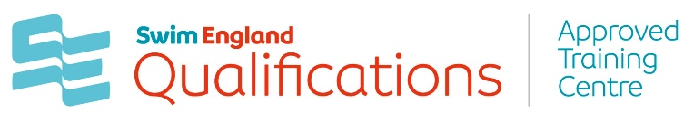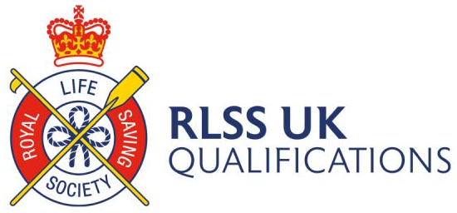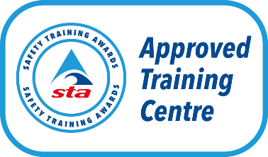



Data Protection Policy
The Data Protection Act 1998 (DPA) was introduced to establish a framework for the
protection of personal or sensitive data and is underpinned by a set of eight principles. By
processing data in accordance with the data protection principles, HALF Fish Training will ensure the safeguarding of data for all individuals engaged with the assessment, delivery and award of HALF Fish Training approved qualification delivery.
Policy aim and purpose
This policy has been designed to draw attention to the different types of personal or
sensitive data which may be processed by HALF Fish Training. In addition, the data processing methods (including the concepts of obtaining, recording, retrieval,
consultation, holding, disclosing and using) utilised by HALF Fish Training, for the
purpose of fulfilling the role of a delivery organisation, are outlined within this policy.
Definition of data
Data refers to information about an individual (referred to as the ‘data subject’) that may be used or processed by HALF Fish Training (referred to as the ‘data controller’) in
order to carry out the awarding function of an Approved Training Centre.

There are two categories:
Personal data
This is information which relates to a data subject who is able to be identified from data or
from data with other information, which is already in possession, or likely to come into
possession of, the data controller. Facts and opinions about the data subject which can be
held electronically or on paper may also be considered as personal data.
Sensitive personal data
This is information about a data subject relating to racial or ethnic origin, political opinions,
religious beliefs, trade union membership, physical or mental health or condition, sex life, the commission or alleged commission of any offence, criminal proceedings or convictions.
The data protection principles
The following eight principles of the DPA must be adhered to when processing personal
data:
1. Personal data shall be processed fairly and lawfully
2. Personal data shall only be obtained for specified and lawful purposes
3. Personal data shall be adequate, relevant and not excessive
4. Personal data shall be kept accurate and, where necessary, kept up to date
5. Personal data shall not be kept for longer than necessary
6. Personal data shall be processed in accordance with the rights of the data subject
under this Act
7. Appropriate technical and organisational measures shall be taken against unauthorised
or unlawful processing of personal data and against accidental loss or destruction of, or damage to, personal data
8. Personal data shall not be transferred to a country or territory outside of the
European Economic Area unless that country or territory ensures an adequate level
of protection for the rights and freedoms of data subjects.

Complying with the data protection principles
To meet the legal obligations of the DPA, HALF Fish Training has in place the following
procedures to ensure the security of data for all individuals engaged with the delivery,
assessment of HALF Fish Training qualification delivery.
♣ All members of HALF Fish Training staff, learners, HALF Fish Training representatives and volunteers have access to a copy of this policy
♣ All forms which require the collection of sensitive or personal data include a data
protection statement to inform the data subject of how their data will be processed
♣ No data is used for the purposes of marketing, unless the data subject provides
written consent to confirm that this is acceptable
♣ No personal data is disclosed, written or verbal, to anybody outside of HALF Fish Training unless written consent from the data subject is provided to confirm that this is acceptable
♣ Only nominated members of HALF Fish Training have access to personal data and process this information in accordance with the requirements of the awarding function
♣ All records are electronically stored, with appropriate protection in place to prevent
unauthorised access from non-HALF Fish Training members of staff
♣ Access to the qualifications database, is restricted with password protection and access rights made available to nominated members of HALF Fish Training and the Awarding Body, on request, with passwords reset regularly.
♣ Learner achievement data will be uploaded to the personal learning record if the data subject has indicated that this is acceptable and a unique learner number has been provided to HALF Fish Training.
♣ Access to view information contained within the personal learning record is limited to authorised users, of which they have been vetted prior to authorisation.
♣ Learner achievement data is not used for any other purpose other than those
permitted in this policy, including marketing or financial gain
♣ All records are kept accurate and up to date as far as practicable; HALF Fish Training and in turn the Awarding Body relies on the data subject to communicate any changes to personal data as and when applicable
♣ Should HALF Fish Training at any point send an email to multiple individuals, those individuals will be blind copied into the correspondence.

How we use your information
Personal data collected will solely serve the purpose of enabling HALF Fish Training to carry out the requested activity. By submitting information to us, you are authorising HALF Fish Training to process your data accordingly. Should contact information be provided, you consent to receiving information relating to the requested activity by email, post or telephone unless stated otherwise.
Security of data
HALF Fish Training has in place appropriate measures to ensure the safety of stored data to prevent unauthorised use or disclosure. In the event of a breach of security (i.e. theft, deliberate attack on systems, unauthorised use of personal data by a member of staff, accidental loss or equipment failure), a recovery plan will be implemented. This will include procedures for assessing the risk associated with the breach, reviewing and updating security measures and notifying those individuals affected.
Personal learning records
The personal learning record is an internet-based register of learners and achievement data, designed to assist learners with their personal learning development. It allows learners to view their education and training qualifications in one place. A unique learner number (ULN) is required to access a record and is completely unique to each learner.
HALF Fish Training as an Approved Training Centre is responsible for creating and providing a valid ULN for those learners who do not already possess one, if they request it. It is also the responsibility of HALF Fish Training, as the Approved Training Centre to inform learners that their data will be processed for the purpose of creating a ULN and updating their personal learning record. This notification will take place in the form of a privacy notice as identified below.
Privacy notice
All Awarding Body Approved Training Centres, of which HALF Fish Training is one, are required to inform learners of how their data will be processed for the purpose of registration and certification of a qualification. A privacy notice is required to inform learners of how their data will be processed for the purposes of the personal learning record. As a minimum, the Awarding Bodies have put the following statement in place, “Our Approved Training Centres will provide the following statement to learners at the point of application or registration onto a qualification, along with the opportunity to opt out if they do / not want to share their data.”
“Some of the information you supply will be used by Skills Funding Agency to fulfil its
statutory functions, issue/verify your unique learner number (ULN) and update/check your
personal learning record. The Skills Funding Agency may share your ULN and personal
learning record with other education related organisations, such as careers service, school,
college, university, government departments and public bodies responsible for funding your
education. Further details of how your information is processed and shared can be found at
https://www.gov.uk/government/publications/lrs-privacy-notices.
Further information on the personal learning record and how data is used and shared is set
out below. For those individuals who wish to fully understand the implications of sharing
data, further information is contained within the Extended Privacy Notice directly from
Learning Records Service.
♣ Some of the information you supply will be used by the Skills Funding Agency to fulfil
its statutory functions, issue/verify your ULN and update/check your own personal
learning record.
♣ Your personal learning record will include information about your qualifications, awards,
training and learning achievements that you may collect throughout your lifetime – at
all levels and also whilst you are working and learning.
♣ Your personal learning record can be shared with organisations who have a
responsibility for providing, funding and serving your education and training.
♣ If you are below the age of 16, you might wish to discuss this privacy notice with your
parent or legal guardian.
♣ The Skills Funding Agency is a public body that funds qualifications and training that
you may be receiving. It is responsible for maintaining ULNs and personal learning
records on behalf of all individuals aged 13 and above in England and Wales.
♣ Your ULN is a ten digit reference number, which is unique and individual to yourself
for use within education. Please keep this number in a safe place.
♣ It is used to create and update your own personal learning record, which will be
conveniently located online for you to access at
www.learningrecordsservice.org.uk/products/learnerrecord/
♣ The Skills Funding Agency may obtain and use third party reference data to assist
when verifying your ULN and when checking that the data it holds about you is
correct, in order to comply with the requirements of the Data Protection Act to keep
your details accurate and up to date.
♣ The Skills Funding Agency may use your information for management and statistical
purposes and for monitoring the accuracy of the information it holds about you.
♣ The Skills Funding Agency may share your ULN and personal learning record
information with other education related organisations such as your careers service,
school, college, university, Government departments and public bodies responsible
for funding your education.
♣ Please note that you can opt-out of the Skills Funding Agency sharing your personal
learning record. You may not however opt-out of the Skills Funding Agency storing
your information.
♣ You can opt-out of sharing your participation and achievement data by contacting the
Learning Records Service customer helpdesk on 0845 602 2589. You will be
required to provide some personal details to confirm your identity, which may include
your ULN, if known.

HALF Fish Training has undertaken an Independent Commissioners Office (ICO) Data survey and was awarded a green for compliance. We follow the guidelines given by the ICO regarding the processing of data from our learners on our courses.

Monitoring and review
This policy and its procedures will be reviewed annually, to ensure that it remains fit for
purpose and in line with the requirements of the DPA and recommendations made by the ICO.

For Office Purposes | Document | Version Number | Comments on Amendments and/or Additions | Published Date
 | Data Protection Policy | 7 | Updated Policy / Review | April 2025
 | Data Protection Policy | 8 | Annual Review | April 2026

Documents and Forms linked to this policy :-
- HALF Fish Training Equality and Diversity Policy
- HALF Fish Training Data Protections Policy
- HALF Fish Training Document Retention Policy
- HALF Fish Training Complaints Policy
- HAF Fish Training Learner Initial Assessment Form
- HALF Fish Training Skills Test Form
- HALF Fish Training Interview / Skills Test Reasonable Adjustment Notes Form

Sources of Information
- RLSS UK Qualifications Guidance Documents
- Swim England Qualifications Documents
- Safety Training Awards Qualification Documents
- www.gov.uk education and skills funding agency – learner records service
- Independent Commissioners Department

